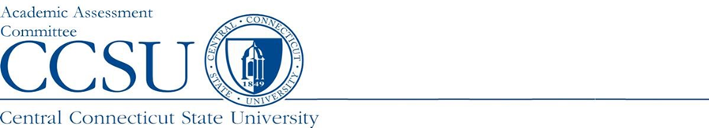

Program report Summary

Department: | Report Type: SUMMARY
Program Name: | Degree Award Level:
Report Preparer: | Academic Year Data: 2022-23
Program Structure: Choose an item. | Date Report Completed: Click or tap to enter a date.
Accreditation Agency (If Applicable): | Semester/Year Next Self Study Due:

Program Assessment Question | Response
- URL: Provide the URL where the learning outcomes (LO) can be viewed. | Type URL here:
- Assessment Instruments: Please list the source(s) of the data/evidence, other than GPA, that is/are used to assess the stated outcomes? (e.g., capstone course, portfolio review and scoring rubric, licensure examination, etc.) | List assessment instruments here:
3) Interpretation: Who interprets the evidence? (e.g., faculty, Admin. assistant, etc.). | Who interprets the data?
4) Results: Since the last submitted report, list:  a. The conclusion(s) drawn, noting strengths and weaknesses.  b. The changes that were or will be made as a result of those conclusion(s). | What changes were made last year?  What are the results of those changes?
- Strengths: What about your assessment process is working well? | What are the strengths of the program?
- Improvements: List ways in which your assessment process needs to be improved based on student data. (A brief summary of changes to assessment plan can be reported here) | What improvements will be made this year as a result of the assessment data?
- General Education Assessment: Please list the department faculty who have participated in our General Education Assessment Initiative. (For graduate degree programs, please type N/A.) | If applicable, list Faculty member(s) participating in our GenEd Assessment Initiative:

End of Report

