**Cone of Active Learning**

***Objective:*** *To identify the differences between active and passive learning as well as understand the impacts of these levels of engagement*

The diagram below indicates the effectiveness of different learning activities – the percentages represent what we tend to remember after two weeks with respect to each learning activity. Therefore, our ability to recall depends on the type of engagement with what is learned.

**Active learning** is defined as being engaged in learning with an interest and intent to remember information.

**Are your current strategies more active or passive forms of learning?**

[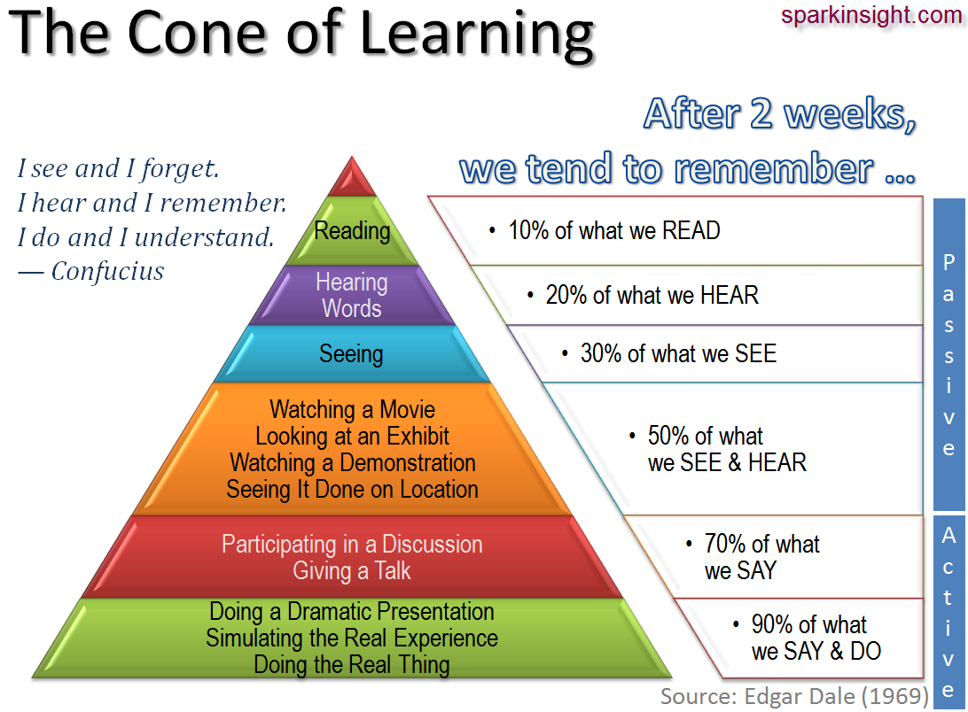](http://sparkinsight.wikidot.com/local--files/factlets/cone_of_learning.png)

**P**

**A**

**S**

**S**

**I**

**V**

**E**

**lectures, etc.**

**movies; illustrated**

**lectures; tours, field trips,**

**on location to watch how**

**something is done; demonstrations**

**viewing art,**

**graphs, maps, etc.**







**How will you adjust your study habits to practice more active learning?**

**______________________________________________________________________________________________________**

**______________________________________________________________________________________________________**

**______________________________________________________________________________________________________**

**A**

**C**

**T**

**I**

**V**

**E**

**live practicing, dramatic presentations;**

**simulations; tutoring**

**giving a talk; multi-media programs;**

**group discussions**



